Bootcamp Evidence

# BC1 – Ex1

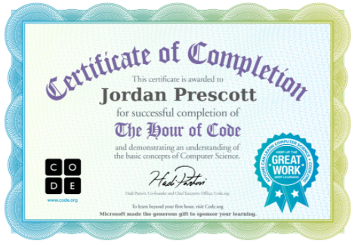

# BC1 – Ex2

public class HelloWorld

{

public static void main(String[] args)

{

System.out.println("Hello World");

}

}

# BC1 – Ex3

public class HelloWorld

{

public static void main(String[] args)

{

System.out.println("Hello Matt Sharldow.");

System.out.println("Hello Connah Kendrick.");

System.out.println("Hello Jordan Prescott.");

System.out.println("Hello Avtar Marway.");

System.out.println("I am a computer running some code.");

}

}

# BC2 – Ex1

My Age - 23

My Age Binary - 10111

Highest decimal number

Binary - 64 | 32 | 16 | 8 | 4 | 2 | 1

Bits on - 1 | 1 | 1 | 1 | 1 | 1 | 1

Bits added together = 64 + 32 + 16 + 8 + 4 + 2 + 1 = 127

# BC2 – Ex2

|  |  |
| --- | --- |
| 0 | 0 |
| 512 | 1000000000 |
| 950 | 1110110110 |
| -20 | -10100 |
| 2147483647 | 1111111111111111111111111111111 |
| -2147483647 | -1111111111111111111111111111111 |
| 1073741824 | 1000000000000000000000000000000 |

# BC2 – Ex3

|  |  |
| --- | --- |
| int a = 1;  int A = 2; |  |
| int var = 1;  int var = 2;  float var = 3.0f; |  |
| int var1 = 1;  int 2var = 2; |  |
| int camelCaseStyle = 1;  int snake_case_style = 2; |  |
| int a = 1  int b = 2; |  |
| int a;  int b = 2; |  |
| int a = 1.1; |  |

# BC2 – Ex4

|  |  |
| --- | --- |
| int a = 67;  float b = a;  double c = b;  System.out.println(a);  System.out.println(b);  System.out.println(c); | 67  67.0  67.0 |
| float a = 101.01f;  float b = (float)101.01;  System.out.println(a);  System.out.println(b); | 101.01  101.01 |
| char a = 67;  System.out.println(a); | c |
| float a = 101.01f;  float b = (float)101.01;  double c = 101.01;  double d = a;  double e = b;  System.out.println(a);  System.out.println(b);  System.out.println(c);  System.out.println(d);  System.out.println(e); | 101.01  101.01  101.01  101.01000213623047  101.01000213623047 |
| int a = (int)'~';  System.out.println(a); | 126 |
| int a = (int)'{'; System.out.println(Integer.toString((int)a,2)); | 1111011 |

# BC2 – Ex5

Error I got from 2147483648:

Exception in thread "main" java.lang.Error: Unresolved compilation problem:

The literal 2147483648 of type int is out of range

at Exercise_5.main(Exercise_5.java:6)

When I changed to 7 the variable was fine.

# BC2 – Ex6

Just like the PSY video clip if a number overflows this can give false results. After

researching it looks like it can be more fatal and actually compromise the security of a program

money is very important and banks need to be flawless. YouTube I think can take a hit on the number

of videos not being correct but if this was to flaw security for a bank this is huge.

# BC2 – Ex7

My name in bindary - 1001010 1101111 1110010 1100100 1100001 1101110

# BC3 – Ex1

1. The public class had issues with spelling, upper case and did not match the module.
2. Square brackets where used instead of curly ones.
3. On the entry point again misspelling and curly brackets and square brackets were mixed.
4. In the print line “” were placed incorrectly and brackets missing for arithmetic.

Final Code:

public class Errors

{

public static void main(String [] args)

{

System.***out***.println("1 + 1 is: " + (1 + 1));

}

}

# BC3 – Ex2

public class SwimmingPool {

public static void main(String [] args)

{

int length = 25;

int width = 10;

int depth = 2;

System.***out***.println(

"A pool of length: " + length + "m, width " + width + "m and depth " + depth + "m will require " + ((length * width * depth) * 1000) + " litres of water to fill it."

);

}

# BC3 – Ex3

|  |  |  |
| --- | --- | --- |
| a + b * c | 22 | 22 |
| 39 / a + b | 9 | 9 |
| (a + b) * c | 32 | 32 |
| 3 * (5 + b) /c | 2 | 16 |
| a - 11 * c / b | 7 | 7 |
| a * b + b / c - 1 | 62 | 62 |
| 27 % 3 + c | 2 | 2 |
| 2 * a % -3 | -6 | 2 |